Yoga and Beer Event

Relax, Refresh, and Rejuvenate!

# Join Us for Yoga and Beer!

Date: February 16, 2025

Time: 10:00 AM – 11:00 AM

Location Mad Hatchet Brewing, 913 Brook Forest Ave Shorewood IL 60404

$20 1 hour of Yoga and 1 pour of beer (after class)

Come and experience a unique blend of relaxation and enjoyment at our Yoga and Beer event. Whether you're a seasoned yogi or a beginner, this event is perfect for everyone who loves to unwind with a cold brew after a fulfilling yoga session.

## Event Highlights:

* Invigorating yoga session led by Melody Roberts, Sacred Path Yoga
* Refreshing craft beers from Mad Hatchet Brewing
* Peaceful and welcoming environment
* Opportunity to meet and connect with like-minded individuals
* Please bring your own mat
* Class size limited to 15 people

Don't miss out on this perfect harmony of mindfulness and fun. Bring your yoga mat and a friend, and get ready to stretch, sip, and socialize!

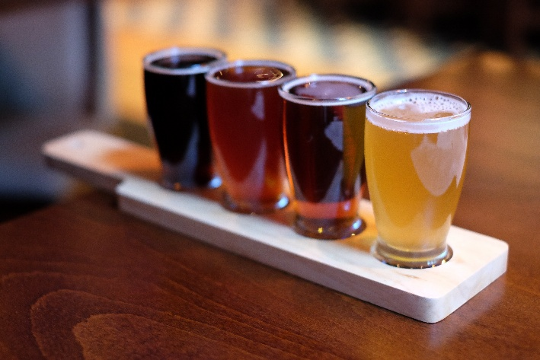For more information, visit our website or contact us at

Brewery phone [(779) 234-9123](https://www.google.com/search?q=mad+hatchet&sca_esv=5791a0164e19b13c&sxsrf=AHTn8zr1MOOZA5IH2tjeUuhXPo4Mv8Ce7Q%3A1737642514021&source=hp&ei=EVKSZ4L9O6nFp84Pg8G_sAY&iflsig=ACkRmUkAAAAAZ5JgIhZa8Juks_mLBoRHE5fqmWMakxvZ&gs_ssp=eJzj4tVP1zc0TM_LMDc1qDI2YLRSNaiwsDBItUiyMLAwTk5JMjI2tzKoSDEzME0xtkxKtUhONTVOTvbizk1MUchILEnOSC0BAGrbE2I&oq=mad+hatchet&gs_lp=&sclient=gws-wiz)

[Infomadhatchet@gmail.com](mailto:Infomadhatchet@gmail.com)

Namaste and Cheers!